Platinum Import Procedure

- Move G/L & Original A/R
- From the start menu, choose Programs: GIS: Accounting File Mover.
- Select the RBR date you want to import from the list.
- Click on the Next button.
- Check that the arrow is pointing to All G/L & Original A/R Invoices.
- Import G/L transactions
- From the Start menu, choose Programs: Platinum SQL42 Client: Platinum SQL.
- Log in with the sa account.
- From the Import menu, choose GL Import: GL Transactions.
- Select “Import Daily GL Transactions” from the list.
- Click on the Process button and wait for the report.
- Check that the report lists 1 correct transaction and 0 wrong transactions.
- Close the report window. (You don’t need to save the results.)
- Post G/L transactions
- From the Applications menu, choose General Ledger.
- From the Processing menu, choose Standard Transactions: Post Standard Transactions.
- Select “GIS IMPORTED” in the Journal Selection box and click the Add button.
- Click the Post button and wait for the report.
- Close the report window. (You don’t need to save the results.)
- Print the G/L Transaction report
- From the Reports menu, choose Transaction.
- Select Today’s Transactions.
- Click the Process button.
- Under Ranges, change the Apply Date to the RBR date that you selected in step 1.
- Click the OK button and wait for the report to complete.
- From the File menu, choose Print.
- Close the report window. (You don’t need to save the results.)
- Close the General Ledger application.
- Import A/R original invoices
- From the Import menu, choose AR Import: AR Invoices/Credit Memos.
- Select “1. Import Post Invoices” from the list.
- Click on the Process button and wait for the report.
- Print the report to printer by clicking the printer button.
- Check that the report does not contain any errors.
- Close the report window. (You don’t need to save the results.)
- Import A/R original credit notes
- From the Import menu, choose AR Import: AR Invoices/Credit Memos.
- Select “2. Import Post Credit Notes” from the list.
- Click on the Process button and wait for the report.
- Print the report to printer by clicking the printer button.
- Check that the report does not contain any errors.
- Close the report window. (You don’t need to save the results.)
- Move A/R adjustment files to Platinum’s import directory.
- Switch windows to the Accounting File Mover
- Click the Next button
- Check that the arrow is pointing to A/R Adjustments.
- Import A/R adjustment invoices
- From the Import menu, choose AR Import: AR Invoices/Credit Memos.
- Select “3. Import Post Adj Invoices” from the list.
- Click on the Process button and wait for the report.
- Print the report to printer by clicking the printer button.
- Check that the report does not contain any errors.
- Close the report window. (You don’t need to save the results.)
- Import A/R adjustment credit notes
- From the Import menu, choose AR Import: AR Invoices/Credit Memos.
- Select “4. Import Post Adj Credit Notes” from the list.
- Click on the Process button and wait for the report.
- Print the report to printer by clicking the printer button.
- Check that the report does not contain any errors.
- Close the report window. (You don’t need to save the results)
- Close the Accounts Receivable application.
- Print the GL Balancing Report
- From the Applications menu, choose General Ledger.
- From the Reports menu, choose General Ledger.
- Select “GIS Import Control Account”.
- Click the process button.
- Select “Summary”.
- Click the ok button.
- Enter the “Begin Period” and “Through Period” dates.
- Click the ok button and wait for the report.
- Print the report to printer by clicking the printer button.
- Close the report window. (You don’t need to save the results)
- Close the General Ledger application.
- Place numbers from the reports into a Balancing Summary
- Open Excel Program at - START –PROGRAM – Excel
- Open Spreadsheet “GIS_AR_BAL”.
- Change the title to the correct Date.
- Fill in the numbers from the above reports.
- The “Out Of Balance Amount” should be 0.00.
- Print out the results.
- Print the Invoice report
- Switch windows to the Platinum System Manager.
- From the Applications menu, choose Accounts Receivable.
- From the Reports menu, choose Operational: Posted: Invoice.
- Select Today’s Invoices.
- Click the Process button.
- Under Ranges, change the Apply Date to the RBR date that you selected in step 1.
- Click the OK button and wait for the report to complete.
- From the File menu, choose Print.
- Close the report window. (You don’t need to save the results.)
- Print the Credit Memo report
- From the Reports menu, choose Operational: Posted: Credit Memo.
- Select Today’s Credit Memos.
- Click the Process button.
- Under Ranges, change the Apply Date to the RBR date that you selected in step 1.
- Click the OK button and wait for the report to complete.
- From the File menu, choose Print.
- Close the report window. (You don’t need to save the results.)
- Close the Accounts Receivable application.
- Clean up
- Switch windows to the Accounting File Mover
- Click the Next button
- If you need to keep the data files for the day you just imported, make sure the check box is not checked. If you don’t need to keep them, make sure the check box is checked.
- Click the Next button
- If you want to import another day, go back to step 1, otherwise close the Accounting File Mover and Platinum System Manager applications.

Troubleshooting
Here are the problems that can occur for each step and how to resolve them:

Step 1.
- “There are no files to import”, “Bad file name”, or “File not found”. Click the options button and check that the Accounting File Mover is looking in the right directories. Ask your system administrator to check that the accounting files are being exported correctly.

APPENDIX A

Import Daily GL Transaction Setup

1. Setup of the Import G/L transactions
- From the Start menu, choose Programs: Platinum SQL42 Client: Platinum SQL.
- Log in with the sa account.
- From the Import menu, choose GL Import: GL Transactions.
- Click on New.
- Click on Parameters.
- Click on Processing Options.
- Fill in the parameters as shown below.

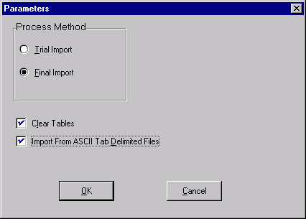
- Click on the ok button.
- Click on the ok button.
- Click on the ok button.
- Click into “Configuration Name”.
- Type in “Import Daily GL Transactions”.
- Click on the save button.

APPENDIX A

1. Import Post Invoices Setup

1. Setup of the Import A/R Invoices
- From the Start menu, choose Programs: Platinum SQL42 Client: Platinum SQL.
- Log in with the sa account.
- From the Import menu, choose AR Import: AR Invoices/Credit Memos.
- Click on New.
- Click on Parameters.
- Click on Processing Options.
- Fill in the parameters as shown below.

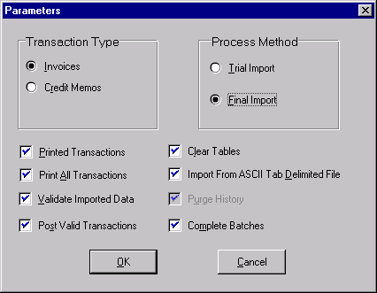
- Click on the ok button.
- Click on the ok button.
- Click on the ok button.
- Click into “Configuration Name”.
- Type in “1. Import Post Invoices”.
- Click on the save button.

APPENDIX A

2. Import Post Credit Notes Setup

1. Setup of the Import A/R Invoices
- From the Start menu, choose Programs: Platinum SQL42 Client: Platinum SQL.
- Log in with the sa account.
- From the Import menu, choose AR Import: AR Invoices/Credit Memos.
- Click on New.
- Click on Parameters.
- Click on Processing Options.
- Fill in the parameters as shown below.

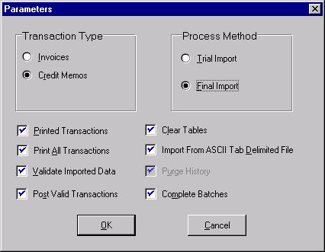
- Click on the ok button.
- Click on the ok button.
- Click on the ok button.
- Click into “Configuration Name”.
- Type in “2. Import Post Credit Notes”.
- Click on the save button.

APPENDIX A

3. Import Post Adj Invoices Setup

1. Setup of the Import A/R Invoices
- From the Start menu, choose Programs: Platinum SQL42 Client: Platinum SQL.
- Log in with the sa account.
- From the Import menu, choose AR Import: AR Invoices/Credit Memos.
- Click on New.
- Click on Parameters.
- Click on Processing Options.
- Fill in the parameters as shown below.

- Click on the ok button.
- Click on the ok button.
- Click on the ok button.
- Click into “Configuration Name”.
- Type in “3. Import Post Adj Invoices”.
- Click on the save button.

APPENDIX A

4. Import Post Adj Credit Notes Setup

1. Setup of the Import A/R Invoices
- From the Start menu, choose Programs: Platinum SQL42 Client: Platinum SQL.
- Log in with the sa account.
- From the Import menu, choose AR Import: AR Invoices/Credit Memos.
- Click on New.
- Click on Parameters.
- Click on Processing Options.
- Fill in the parameters as shown below.

- Click on the ok button.
- Click on the ok button.
- Click on the ok button.
- Click into “Configuration Name”.
- Type in “4. Import Post Adj Credit Notes”.
- Click on the save button.

APPENDIX B

Report Samples

